Version 1.0 | SYSTEM ARCHITECTURE

Table of Contents
1 Executive Summary 4
1.1 Purpose and History 4
1.2 Project Objectives 4
1.3 Intended Audience 4
1.4 Assumptions 4
1.5 Contributors 5
2 Architectural Overview 6
2.1 Architecture Scope 6
2.2 Business Process Model (BPM) Overview 6
2.3 Architectural Drivers (i.e. Interoperability, Extensibility, Availability, etc.) 6
2.4 Integration Type 6
2.5 Impacted Architectural Domains 6
3 Logical Architecture 7
3.1 Conceptual Models 7
3.2 Logical Models 8
3.3 Technology Inventory 8
3.4 Architectural Dependencies 8
4 Hardware Architecture 9
4.1 Tiers 9
4.2 Client Hardware Models 9
4.3 Server Hardware Models 9
4.4 Mass Storage Devices 9
4.5 Peripheral Equipment Models 9
4.6 Additional Models 9
5 Network Architecture 10
5.1 Overview 10
5.2 Technology / Details 10
5.3 Traffic Flow 10
6 Security Methodologies and Requirements 11
6.1 Security Overview 11
6.2 Identity Management Methods & Models 11
6.2.1 User Authentication 11
6.2.2 System Authentication 11
6.2.3 Authorization 12
6.2.4 Provisioning 12
6.3 Information Security 13
6.4 Application Logging 14
6.5 Remote Access Requirements 14
7 Communications Architecture 15
7.1 Communications Model 15
7.2 Interface API’s 15
7.3 Message Management & Queuing 15
7.4 Interfaces 15
Terraform Enterprise Integration with GitHub Enterprise 15
Terraform Integration with Puppet 15
Jenkins integration with GIT 15
Jenkins integration with Terraform and Packer 16
Jenkins integration with Infoblox 16
Jenkins integration with VSphere 16
Jenkins integration with Puppet 16
Jenkins integration with InSpec 16
Integration with Active Directory for domain joining VMs 16
Integration with Monitoring 17
Integration with Patch management 17
Integration with Antivirus 17
Integration with Backup 17
8 Data Architecture 18
8.1 Data Architecture Model 18
8.2 Relational Databases 18
8.3 File Stores 18
8.4 Transaction Management 18
8.5 Content Management Architecture Model 18
8.6 Business Intelligence 18
9 User Interface Architecture 19
9.1 User Interface Summary 19
9.2 Navigation 19
9.3 User Interface Architecture 19
10 Operational Management Architecture 20
10.1 Production Support 20
10.1.1 System Management 20
10.1.2 System Monitoring 20
10.2 Patch Management 20
• Datadog agents will be installed on all VMs deployed from Terraform. 20
10.3 Deployment 20
10.4 Startup and Application Recovery 20
10.5 High Availability 20
10.6 Disaster Recovery 20
10.7 Mechanisms for Quality Requirements 20
11 Performance Architecture 21
11.1 Load Balance Model 21
11.2 Pooling Techniques 21
11.3 Hardware & Software Distribution and Management Plan 21
11.4 Architecture Scaling Model (Scale-Up or Scale-Out) 21
11.5 Load Testing Mechanisms 21
12 Vendor Related Information 22
12.1 Vendor Overview 22
12.2 Proprietary Communication 22
12.3 Proprietary Database Formats 22
13 Development Architecture 23
13.1 Language Stack 23
13.2 Design Patterns 23
13.3 Tools Used 23
13.4 Third Party or Open Source Libs 23
13.5 Versioning Strategy 23
13.6 Source Code Management and Packaging 23
14 Approvals 26
15 Appendix 27
15.1 Architecture Decisions 27
15.2 Requirements Trace 27
15.3 Major Unresolved Issues 27
15.4 TBD’s 27

Revision History
Version | Date | Author(s) | Summary of Changes
1.0 | 07/18/17 | Daniel Solomon | Document creation
1.1 | 10/27/17 | Arun Kumar. S | Architecture Feedback
1.2 | 11/8/2017 | Venkatesan Ramanathan | Document update as per feedback
1.3 | 12/7/2017 | Arun Kumar. S | Architecture Review Completed

Executive Summary

Purpose and History

The purpose of having an Infrastructure as code , in-lieu of Infrastructure automation platform is as follows
- While Infrastructure automation solution cater to provisioning / orchestration and automation, they do not maintain information about the provisioned resources for on-going management
- Infrastructure automation solution does not document and version control the changes made to the provisioned resources
- Infrastructure automation solution provides API , which allows remote trigger/execution of orchestration workflows. However the Infrastructure provisioning code is not exposed through the API, and hence limit the possibility of modifying infrastructure provisioning , as part of application build / deploy pipeline.

Infrastructure-as-code overcomes the above short-comings of Infrastructure automation, by keeping state information of the provisioned infrastructure, and treating infrastructure as a code which can be version controlled, validated and tested.

Project Objectives

The objective of this project is to introduce IAC practice to 5/3 through the Hybrid cloud program, and to decrease the time taken to provision windows and linux servers, by embracing end-to-end automation. The IAC framework would also enable the business to be more agile by offering alternate development statck (such as Jboss)

Intended Audience
- Infrastructure automation engineer
- Infrastructure architect
- Cloud architect
- Enterprise Architecture Office
- IT Architecture Council (ITAC)
- Environment Management Team (EMT)
- Production Readiness
- Project Managers
- IT Business Line Liaisons

Assumptions
- Service provisioning on-premises and off-premises (AWS) will be managed through the Infrastructure-as-code automation platform, and requested through Remedy
- Day 2 operations on resources provisioned on-premises and off-premises (AWS) will be managed through the Infrastructure-as-code automation platform, and requested through Remedy
- User access to provisioned resources will be handled using existing access management system (i.e., MyAccess)
- Resource reclamation or deprovisioning of resources will be requested through Remedy and handled by the IAC automation platform
- GIT Tool (open source) will be used as the Source code management tool for infrastructure code, till such time the enterprise edition of GITHUB is implemented at Fifth Third Bank
- Openstack Glance will be used for Image metadata management and the actual images will be stored in a repository setup on top of NAS file share
- Terraform will be used as the Provisioning automation tool
- Jenkins will be setup in 5/3 as the tool for Build orchestration
- Packer will be used to package the OS image for both Windows and Linux
- Inspec will be used as the infrastructure Test automation tool

Contributors
The following individuals contributed to the content of this document:
Name | Type | Phone | E-mail
Dan Solomon | Author | 513-358-0236 | Daniel.Solomon@53.com
Venkatesan Ramanathan | Co-Author | 513 358 0237 | Venkatesan.ramanathan@53.com

Architectural Overview

Architecture Scope
The Architecture scope is limited to setting up the Infrastructure-as-code automation platform for performing the following tasks
- Build and test cycle for Infrastructure code
- Provisioning / deployment orchestration

Business Process Model (BPM) Overview

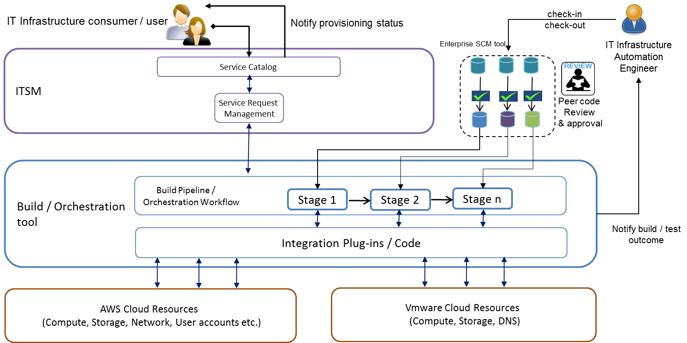

OS Image Build & Provisioning 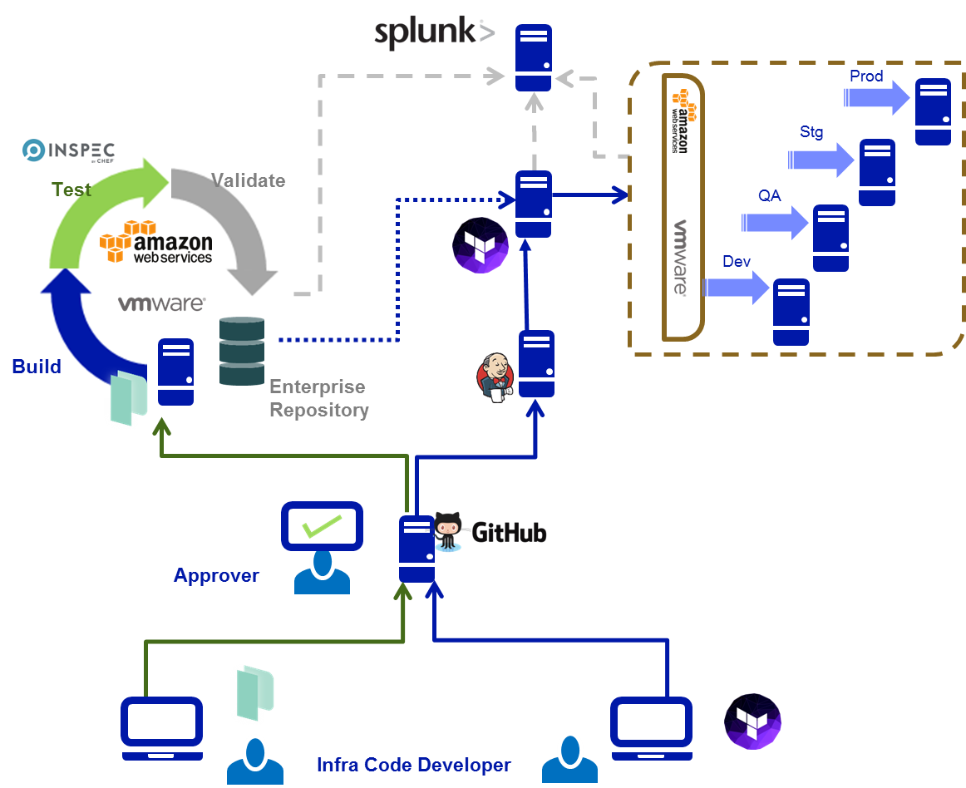

Architectural Drivers (i.e. Interoperability, Extensibility, Availability, etc.)

Maintainability
- OS image build and update is simplified by use of packer tool, which can compile image formats for target technology platform from a single source configuration file
- Terraform allows for easy creation and/or modification of infrastructure, such as new subnets, security goups, VMs
- Terraform helps visualize infrastructure changes before implementation, and it is possible to rollback to previous infrastrucuture configurations
- Image validation and validation of customization performed on provisioned VMs, through Inspec tool
Interoperability
- Terraform uses a descriptive language that can be used to specify the target state for a resource to be provisioned
- By virtue of usage of a common descriptive language for resource provisioning, across multiple technology platforms, interoperability is ensured
Extensibility
- Terraform is built on open standards and hence is extensible
- Terraform uses the native APIs of technology platforms as the interfacing
Mechanism, which enables extension of the automation platform for provisioning
services for which native APIs are exposed by the cloud provider
- AWS resource state information can be imported into Terraform, and hence even manual configurations applied to AWS can be updated to keep the Terraform state information accurate.
Availability
- Terraform and packer are single package binary files, and hence it is easy to
recover from failure (by restoring the binary file)
- Terraform maintains the state information of the provisioned infrastructure in a state file, which can be replicated to a different location, there by ensuring quick turn around time for recovering from failure
- Remote backend will be enabled for Terraform, in order to make the terraform state file available on a remote object store (AWS S3 bucket), there by ensuring availability of the state information of the provisioned infrastructure

Integration Type
This solution will integrate with the following IT infrastructure components
- AWS (via Terraform provisioner)
- Vmware (via Terraform provisioner)
- Remedy ITSM (via remedy AR Soap API)
- Infoblox (via REST API)
- Glance Image repository (via REST API)
- Git server (Via GIT tool)

Impacted Architectural Domains
- Active Directory
- DNS
- Monitoring
- Backup
- Private cloud compute platform
- AWS
- Antivirus
- Patch management
- IT service Management tool
- Qradar (Vulnerability management)
- Splunk (Log management)

Logical Architecture
This section should include descriptions of how conceptual software pieces and interfaces will work together to achieve the goals of the architecture. Please do not articulate hardware architecture in this section. This section should be written from the perspective of the administrators of the conceptual pieces and interfaces.

Conceptual Models
The hybrid cloud automation platform comprises of components that enable the development, test, release and consumption of infrastructure as code. The core components that make up the automation platform are:
- SCM tool (Git tool)
- Build orchestration tool (Jenkins)
- Provisioning tool (Terraform)
- Image validation tool (Inspec)
- Image repository (Glance)
The other components that require integration with the core automation platform are:
- ITSM (service request management and service catalog)

Components | Use cases
SCM | To s1. Store and version control infrastructure code  Diff2. Different code repositories for each cloud service offering  Typ3. Type of source code that is stored and version controlled – ProProviisioning templates, post provisioning validation scritps , Image testing scripts, OS/software image packaging scripts  Use4. Maintained by Infrastructure code developers
Build / Orchestration Tool | - Build orchestration – Windows OS, Linux OS and Jboss web server provisioning (for AWS and Vmware)  - Integration with Remedy for fetching cloud service request details
Management tools | - For managing the cloud resources  - Integrates with the build / orchestration tool via plug-in / API for automation of management tasks  - Management tools are not part of the core automation platform  - ITSM (Remedy) is the management tool to which the IAC framework is integrated with

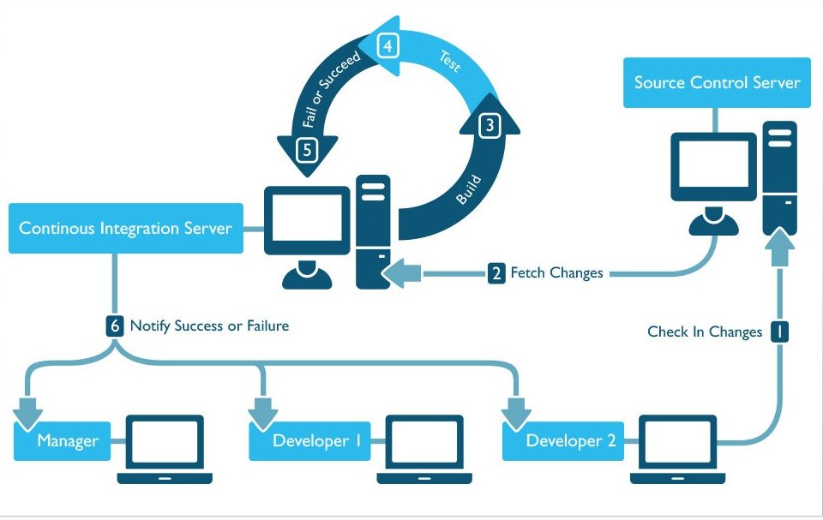

- The Infrastructure code developer develops the source code file using an appropriate IDE or text editor
- The developer then checks-in the code into the Source control server (GIT tool)
- The developer then triggers a Jenkins pipeline (build orchestration tool) to validate and test the developed code
- The Jenkins pipeline downloads the checked-in source code from the source control server and triggers a provisioning process
- The developer monitors the the provisioning outcome (success or failure) through notifications from the build orchestration tool
- The developer updates the source code based on the provisioning outcome.

Logical Models

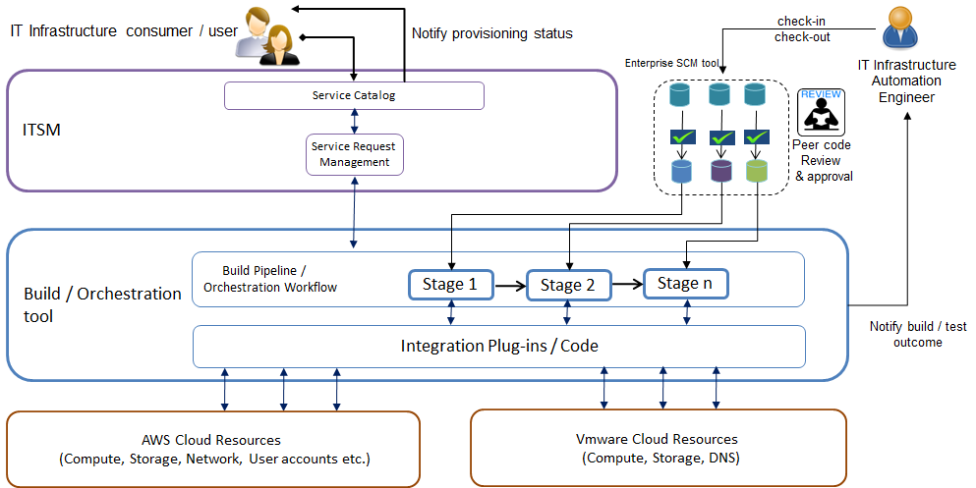

- A cloud service request form will be published in Remedy Service Request management module for ordering cloud services
- The following services can be ordered via the cloud service request form
  - Windows 2012 R2 standard VM provisioning (AWS and Vmware)
  - Red hat Enterprise Linux V7.2 (Vmware) and V7.4 (AWS) provisioning
  - Jboss web server provisioning
- The request will be assigned to the cloud automation queue in Remedy
- The cloud automation queue will be monitored every 15 minutes by a Jenkins Master Pipeline (for assigned requests)
- Jenkins Master pipeline will be polling the SOAP API of Remedy AR system, every 15 minutes
- Jenkins Master pipeline will fetch the list of all tickets assigned to the automation queue and this information will be stored in a database
- Another Jenkins pipeline (Request Processor) will periodically poll the database for assigned requests. If there are any assigned requests, then this pipeline will determine which provisioning pipeline to trigger and it would trigger that particular provisioning pipeline.
- If there are no assigned request then the current cadence of the request processor pipeline will end
- The provisioning pipeline would continue with the provisioning task and report the progress of provisioning back to Remedy, to update the request that was assigned to the cloud automation queue
- If Jenkins provisioning pipeline encounters an issue, then the database is updated with the failure status and the status update is also updated into the Remedy request
- The above model follows the producer-consumer pattern for decoupling the master pipeline (that fetches the remedy request info) from the Request Processor pipeline (which provisions resources in cloud).
- The Jenkins provisioning pipeline will be paramterized to use the Request number and work order number for fetching and updating records in the provisioning database
- At the time of provisioning,the Jenkins pipeline would fetch the latest source code file (peer reviewed and approved) from the production branch of the correspoing repository in the source control server (GIT tools)
- Jenkins would process the user input from Remedy request and enrich it, prior to triggering Terraform for provisioning cloud resources
- Any customizations performed on provisioned cloud resources will be validated using Inspec
- Once the provisioning workflow is completed, The provisioning pipeline would update the status of the Remedy ticket as Completed / Fulfilled. In case of failure, the provisioning pipeline would update the status of the Remedy ticket as failure, so that the Remedy ticket can be assigned to an engineer from the cloud engineering team
- Regardless of the provisioning outcome (success/failure), the provisioning logs are made available for consumption by Fifth Third SIEM processes/tools, by using Splunk log management platform for Log aggregation
- End user notification on cloud service provisioning request will be from the Remedy ITSM tool
- Packer image build process is started from the code update in GitHub. Infrasturcture engineer request peer code review, and commit the change to GitHub branch. Jenkins picks up the corresponding build pipeline, send Packer the build configuration. Packer do a new image build against the code change. Once the new image is validated by InSpec, the new image is published in artifactory.

Technology Inventory
ID | Technology Component | Platform | Application Layer | Description
 | VMware | Virtualization |  | Host on-premises private cloud compute
 | Terraform | Automation |  | Automate provisioning of cloud resources
 | Packer | Automation |  | Automate image build and update
 | InSpec | Automation |  | Automate provisioning validation
 | Git tool | Source code management |  | Storage and version control infrastructure code
 | Jenkins | Automation |  | Orchestrate Infrastructure code build, test and deployment tasks
 | AWS | Cloud service |  | Host Off Prem Innovation Lab

Architectural Dependencies
- IT service management (Remedy)
- Infoblox (DNS & IPAM)
- Internet Proxy (for RHEL Patch updates in AWS)
- Firewall (for allowing communication between IAC and resources deployed in AWS and Vmware platform
- NAS (for storing images used for provisioning)
- AWS S3 (for use as a remote backend for storing provisioning state files)
- AWS KMS (for managing keys used for encryption of functional account credentials)

Hardware Architecture
This section should include details and specifics around existing hardware layouts in all environments of an architecture. This section should include details around any hardware solutions for HA or failover goals. This section should also include details around location and life cycle on the hardware in all environments.

Tiers
N/A – The entire platform is hosted on virtual servers

Client Hardware Models
N/A

Server Hardware Models
N/A

Mass Storage Devices
Existing enterprise storage platform in use at Fifth third bank, will be leveraged.

Peripheral Equipment Models
N/A

Additional Models
N/A

Network Architecture

Overview
General Connectivity to Amazon Web Services (AWS)
- IPSEC VPN tunnel will be established for connecting to AWS
- There will be a primary VPN tunnel and secondary VPN tunnel for each VPC in AWS
- All the VPN tunnels will be terminated on the firewall (on-premises)
- For now, the connectivity is established via the firewall at Grand Rapids site

Connectivity to On-premises private cloud compute platform (Vmware)
- The connectivity to on-premises private cloud compute platform will be handled through the existing DC LAN network connectivity

Technology / Details
- IPSEC tunnel between Grand Rapids Firewall and AWS Virtual private gateway

Traffic Flow
ID | Source IP | Destination IP | Port(s)
5.3.1 | Jenkins server | Git Tool | TCP 443
5.3.2 | Jenkins server | Git Tool | TCP 80
5.3.3 | Internal IP range | Git Tool | TCP 22
5.3.4 | Internal IP range | Git Tool | TCP 9418
5.3.5 | Internal IP range | Git Tool | TCP 8443
5.3.6 | Internal IP range | Git Tool | TCP 8080
5.3.7 | Internal IP range | Git Tool | TCP 122
5.3.8 | Git Tool | NTP server | UDP 123
5.3.9 | Git Tool | SMTP relay server | TCP 25
5.3.10 | Jenkins server | Git Tool | TCP 9418
5.3.11 | Jenkins server | Terraform server | TCP 22
5.3.12 | Jenkins server | Inspec server | TCP 22
5.3.13 | Jenkins server | Packer server | TCP 22
5.3.14 | Terraform server | AWS | HTTPS, HTTP
5.3.15 | Terraform server | Vmware server | HTTP, HTTPS, SSH
5.3.16 | Inspec server | VMs | SSH, TCP-5985, TCP-5986

Security Methodologies and Requirements

Information Security best practices, standards, regulations and industry requirements will be used in the assessment of new or modified systems to reduce security-related vulnerabilities and exposures.

Security Overview
- There will be two environments for IAC
  - IAC Beta or development environment
  - IAC production environment
- The IAC beta and production environment servers will be remotely accessible via SSH
- The IAC offshore and onshore team will have permanent remote logon access to the IAC beta and production environment servers
- Sudo access (for root logon) will be enabled for the onshore team for the IAC beta environment servers
- Prior to production move, the IAC team would identify and submit the list of commands for which power user entitlement is required. The powerbroker will be configured to allow elevated privileges for only those commands (in production environment)
- Functional accounts will be created to allow service-based , API or functional access between IAC and other external sytsems
- The following functional accounts have been created

Functional account name | Role | Use case
fPacker | Functional account for Packer tool | A functional account used by packer for creating an image in AWS AMI marketplace & for building image in Vmware Vsphere platform
fTerraform | Functional account for Terraform tool | A functional account used by Terraform tool for provisioning resources in AWS and Vmware platform
fJenkins | Functional account for Jenkins tool | Function account used by Jenkins for Integration with Remedy (for querying and updating Remedy service request form using Remedy Soap API)

  - fPacker – For packer to perform remote package build
  - fTerraform – For terraform to perform provisioning
  - fJenkins – For Jenkins to integrate with Remedy and other IAC/non-IAC components
- The functional account passwords will be retrieved (using prevailing 5/3 processes) and entered into the IAC system in an encrypted manner. An encryption key (from AWS KMS service) will be used to encrypt the file containing the functional account credentials for the above listed functional accounts. The functional account password will be requested using the existing 5/3 processes, and while the functional account passwords are being entered by the custodian of those credentials, the AWS KMS encryption key will be used to encrypt the file where the passwords were entered.
- Local accounts will be created in AWS which maps to the functional accounts setup within 5/3. Since functional accounts are used for programmatic access (via API) and access to aws management console is disallowed for functional accounts, SSO integration / identity federation is not applicable for functional accounts. Because of this reason, the functional accounts created on-premises (in the existing Identity store) will not be visible to AWS. Hence the need for creating local equivalent functional accounts in AWS IAM. The functional accounts in AWS IAM will map to the functional account in 5/3 identity store.
- The local AWS accounts would provide programmatic access to the AWS API for both the packer and terraform tools
- The functional accounts will be provided administrative privileges on the AWS platform, but interactive/console logon will be disallowed for the functional accounts
- The access and secret keys mapped to the functional account will be encrypted using a symmetric encryption key from AWS KMS
- Terraform and Packer will be setup to fetch the encryption key from AWS KMS and decrypt the file that contains the access and secret keys, in order to programmatically manage AWS using the AWS APIs.
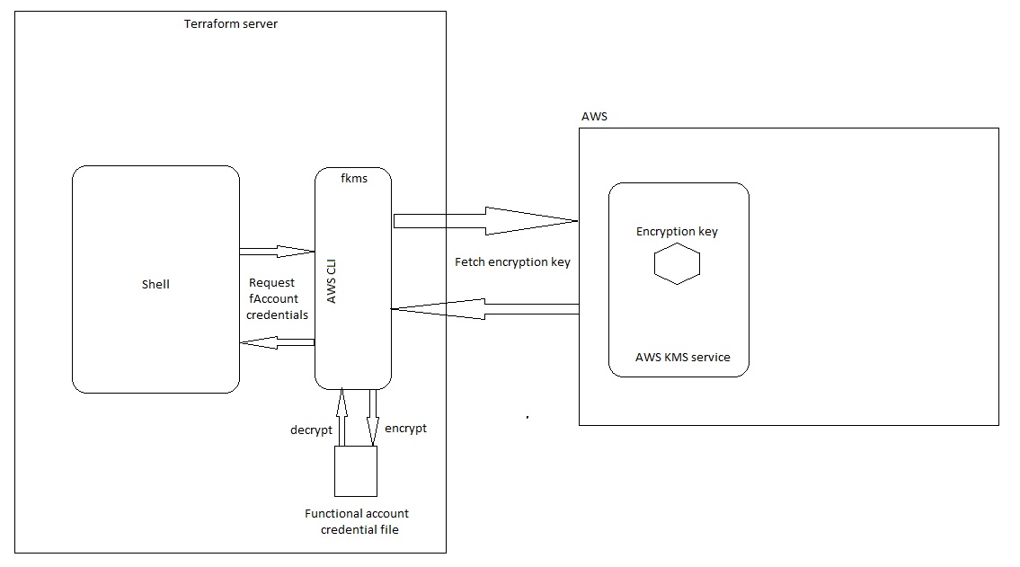

Identity Management Methods & Models

User Authentication
All user access is controlled through entitlements in MyAcess which is then controlled with AD groups within those roles.

Authentication Entry Point  (Intranet, Internet, Mainframe, Internal Network, other) | Authentication  Mechanism
vSphere | Sign on Managed by application
AWS | Sign on Managed by application
Git tool | Sign on Managed by application
Terraform | Sign on Managed by application
Packer | Sign on Managed by application
Jenkins | Sign on Managed by application
Inspec | Sign on Managed by application
Explain “Other” Authentication Mechanism. | Details:

If two-factor or multi-factor authentication is used, describe the additional authentication methods used.  For example: tokens, smart cards | 2FA is not used

System Authentication
System to system and backend data source validation.

Describe authentication methods between applications and backend data sources (2-way SSL, functional ids…) | Details:  1. Jenkins uses functional account for integration with Remedy  2. Terraform uses functional account for integration with Vmware  3. Terraform uses AWS local account for accessing AWS API  4. Packer uses functional account for integration with Vmware  5. Packer uses AWS local account for accessing AWS API  6. Inspec uses either a ssh key or a functional account credentials for validating the VMs provisioned during packer image build  7. Jenkins authentication to local mariadb database is via local db credentials  8. Infoblox authentication is using Jenkins functional account  9. Glance authentication to local mariadb database is via local db credentials

Authorization
Defines the access rights/privileges that have been granted to a user.
Authorization Mechanism
Managed Internally
Explain “Other” Authorization Mechanism
Details: Jenkins authorization with Back-end and Glance authorization with Back-end uses local db credentials and is managed internally
Can user administration functions be segregated from other application functions, including other application administration functions? | Specify Yes or No:
Can user access rights/privileges be extracted or reported on to verify user access? | Specify Yes or No:
Is privileged access required to run or administer the application?  Examples:  - Local Administrator  - Root | Specify Yes or No: | (in Beta environment), but in production, elevated privileges will be restricted to bare minimal commands that are required for operating the IAC components.

Provisioning
Refers to the creation, maintenance and deactivation of user ids and attributes, as they exist in one or more systems, directories or applications through an automated or interactive business process.

If access rights are managed by the internally by the application, describe available mechanisms for automating user access administration. Indicate if an API or batch interface is available. | Details:
 | The functional accounts are setup in Active directory. Rights are managed by Vmware and AWS for RBAC for the functional accounts to the respective platforms, for the Terraform and Packer functional accounts. The Rights for the Jenkins functional account for accessing the Remedy Soap API is managed by Remedy itself. The rights for accessing the glance metadata repository is handled by the keystone component of Openstack that is bundled with Glance.
If users IDs are stored internally, can application support IDs prefixed with special characters (i.e. #)? | Specify Yes or No:
 | If no, describe how existing # IDs will be accommodated.
 | Only functional IDs are used by the IAC components and not user accounts
If access rights are managed internally, are these privileges granted through templates, which are copied to users, or roles, which propagate access rights to users. | Details:
 | Yes (In case of AWS, this is handled by policies associated with the AWS local IAM accounts). In case of Vmware, this is handled through the Vsphere administration console). Keystone service is used for managing access to glance repository from a functional account

Additional Comments:

Information Security
Based on the information classification, different levels of protection are required.

Indicate the information classification that has been determined for the information types (e.g., customer information, user passwords, company confidential) stored, processed or transmitted by this application.

Information  Types | Information  Classification
Infrastructure
Describe the transaction type(s) | Monetary | Non-Monetary | N/A
Is encryption used to protect any restricted data? | Specify Yes or No:
Is Cardholder data transmitted, logged or stored?  Examples:  - Card Number  - PIN  - Card Holder Name  - Expiration Date  - Track 2 credit/debit card data (i.e., card authorization data) | Specify Yes or No:
 | If yes, list all cardholder data elements.
Is encryption used to protect passwords and authenticators both at rest and in transit? | Specify Yes or No:
Are passwords logged? | Specify Yes or No:
Is all Internet traffic encrypted? | Specify Yes or No:
Describe any additional encryption the system utilizes. | Details:
Describe any additional encryption the system utilizes. | The Access and secret keys used by Terraform for AWS API access is encrypted using symmetric encryption keys from AWS KMS service  The functional account passwords of fJenkins, fPacker and fTerraform are encrypted and stored, with encryption keys protected by AWS KMS service

Additional Comments:

Application Logging
Application system logs are created by an application to keep a historical record of events such as transactions processed, users added and deleted, security violations and other information.

Does the application log administration activity? | Specify Yes or No:
Does the application log security violations? | Specify Yes or No:
Does the application log user activities? | Specify Yes or No:
Describe where logs are stored: application database or file, OS file, etc. | Details:
 | Terraform, Packer and Jenkins log files are written to a file system path within the OS, from where it is picked up by the log aggregation tool (Splunk) for further analysis and long-term storage. These logs can be forwarded from Splunk to Qradar for further analysis if required
Describe the reporting features the application provides for printing, retrieving and reviewing application logs. | Details:
 | Terraform logs can be viewed from the log directory on the terraform server. Packer image build logs can also be fetched from the log directory. Jenkins pipeline run logs can be viewed in Blue ocean or from the log directory

Additional Comments:

Remote Access Requirements

Is there a requirement that the application be accessible remotely? | Specify Yes or No:
Is temporary vendor support required? | Specify Yes or No:
Is ongoing vendor support required? | Specify Yes or No:

Additional Comments:

Communications Architecture
This section should include how system interfaces are going to communicate. This section usually includes the details of integrating two (or more) systems. Interface descriptions and any agreed upon communication methodologies should be articulated here. Some examples are: SOAP, RMI, and FTP.

Communications Model
The Intra-communication model for IAC is outlined below
- Jenkins & Terraform – Via Unix shell
- Jenkins & Inspec – Via Unix shell
- Packer & Inspec – Via Unix shell
- Jenkins & Glance – Via Glance REST API

The Inter-communication model for IAC is outlined below
- Jenkins & Remedy – Via Remedy Soap API
- Jenkins & Infoblox – Via Infoblox REST API
- Terraform and Vmware – Via Vsphere API
- Terraform and Packer – Via Vsphere API
- Terraform and AWS – Via AWS API
- Packer and AWS – Via AWS API

Interface API’s
- Jenkins & Glance
Jenkins task integration with Glance is via the REST APIs published by Glance. There are two REST API operations that are utilized
    - GET Images
    - GET Image details
  - The GET Images REST operation is used for searching for a particular image that matches a search criteria. This operation is used to get the Image ID

GET /v2/images?

  - The GET Image details REST operation accepts the Image ID as an input and provides the Image metadata as a response in JSON format. The image metadata is used to identify the Name of the image and File system path (where the image is kept).

GET /v2/images/{image_id}

- Jenkins & Infoblox
Jenkins task integration with Infoblox is via the the REST API published by Infoblox
  - The following REST operations will be used
    - GET Subnet
    - POST available IP address from Subnet
    - POST register hostname against an IP address
  - The GET subnet REST operation is used for identifying the subnet ID for the subnets configured in Infoblox (for private cloud)

GET https://<infoblox_ip>/wapi/v1.2/network

  - A POST rest operation is used to get a next available IP address from Infoblox for a provided subnet ID

POST https://<infoblox_ip>/wapi/v1.2/network/<subnet_id>?_function=next_available_ip

  - A POST rest operation is used to register the hostname against the ip address in Infoblox

POST https://<infoblox_ip>/wapi/v1.2/record:host

- Packer, Terraform & AWS
  - Local AWS IAM accounts will be setup for use by Packer and Terraform components of IAC
  - The local AWS IAM accounts will have only programmatic API access
  - Access to aws management console using the Terraform and packer functional accounts is disallowed
  - In order to protect the access and secret keys associated with the Terraform and Packer functional account, an encryption key will be created and stored in AWS KMS service
  - A functional account will be created in AWS IAM with access to the AWS KMS service alone.
  - AWS CLI will be setup on the Terraform and Packer server
  - The AWS CLI will be configured with the profile associated with the functional account created for AWS KMS access
  - The access and secret keys associated with the Terraform and Packer functional accounts will be stored in a file , and encrypted using the encryption keys from the functional account setup for KMS access
  - Terraform and Packer will always decrypt the file using the encryption key from AWS KMS, and will access the AWS API using the access and secret keys decrypted
  - The encryption key is fetched using AWS CLI which is configured using the fkms functional account (a local account within AWS IAM that has access only to AWS KMS service). The encryption key is accessible only from the AWS API, there by limiting access from the AWS management console. Key protection, management and rotation is handled by AWS (it’s a managed key). The key is referenced using the key id, and is used only at runtime, during provisioning.

- Packer, Terraform & Vmware
  - Packer and Terraform integrate with Vmware using native provisioners / plug-in provided with the Terraform and Packer tools
  - Packer uses standard ‘vsphere’ post-processor plugin to upload and register the image as VM or template. The plugin embedded Go language implementation of vSphere API. Access to vCenter server should have appropriate privilege to create VM and template, write to NFS datastore.
  - Terraform’s stardard vsphere provider communicate with vCenter in the same way as Packer. Access to vCenter server should have appropriate privilege to create VM.

- Jenkins & Remedy
  - Jenkins will be integrated with Remedy to fetch cloud service requests for provisioning
  - Remedy exposes a SOAP API for querying cloud service requests that have been assigned to the Cloud automation queue (a new queue defined in Remedy)
  - A WSDL file provided by the Remedy team will be used to understand the SOAP API interface
  - Jenkins would periodically probe the SOAP API endpoint for cloud service requests and would extract the cloud service request details and store it in a local Mariadb database
  - The Request Processor Pipeline would fetch the oldest assigned request from the database and would trigger provisioning of the requested resource
  - Since AWS provisioning and Vmware provisioning are independent of one another, request for resources in AWS and Vmware can be handled in parallel. But multiple requests for provisioning on the same platform, will be handled in sequence (due to external system dependencies)
  - The provisioning pipeline will be both responsible for provisioning the cloud resource and for notifying Remedy about the outcome of each task defined in the pipeline
  - The SOAP API endpoint (from non-prod) is
http://sugramihqrmdy04/arsys/WSDL/public/sugramihqrmdy01/Tufin_WorkOrder_G_GL_S_FTB
  - A GET LIST Soap operation will be performed to get a list of all work orders assigned to the cloud automation queue in Remedy
  - A PUT Soap operation will be performed to update the Remedy request with provisioning pipeline progress

Message Management & Queuing
No middleware is used in IAC, and hence there is no need for message management and queuing

Interfaces
Interface details are covered in section 7.2 itself

Data Architecture
This section should include details around database layouts, designs, and decisions. Please be sure to include data going to and from the documented system. If a custom database is being designed, please articulate Entity Relationships, Indices, Constraints, Triggers, etc. to help the reader fully understand specific database details around this platform. This view should be written from the perspective of a junior DBA on this platform.

Data Architecture Model

Jenkins will be used to handle control flow between the different tasks in the pipeline. A relational databse (MariaDB) will be used to handle the data flow between the Jenkins tasks

The data fetched from the Cloud service request form will be end-user friendly. This data needs to be transformed into values that the IAC components can understand. The relational database will contain tables that provide a lookup or transformation of the values from the Remedy form to values recognized by IAC components

Relational Databases

The SQL file attached below contains the database schema for storing the data processed by the Jenkins pipeline.

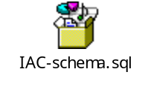

File Stores
The images published by Packer tool will be stored in a NAS file Share, and the image metadata in Glance will be updated with details about the image name / ID and the file system path on the NAS mount where the image is stored. This is applicable only for images built for the vmware platform. In case of AWS, the image metadata would contain only the AMI ID. The file system path is not applicable for AWS images built using Packer. The actual images are stored in an encrypted S3 bucket.

Packer upload built image/artifact to the dedicated NFS datastore of vCenter. The NFS datastore is mounted from DR capable NAS share. At the same time, it can upload to AWS S3 bucket, where the image/artifact will be converted to AWS native AMI format.

A remote backend will be setup in AWS (a S3 bucket) for storing the terraform state file. This will ensure that the terraform state file is available in case of any failure of the Terraform server on-premises.

Transaction Management
N/A

Content Management Architecture Model
N/A

Business Intelligence
N/A

User Interface Architecture
This section should be used to describe any user interface tools and design patterns that were used. Any navigation needs and solutions should be referenced here.

User Interface Summary
- Blue Ocean, a native Jenkins plug-in, will provide an interface for developing Jenkins pipelines.
- Remedy ITSM user interface will be used for configuring service catalog and remedy workflows

Navigation

User Interface Architecture

The cloud service request form that will be used by the end users for submitting provisioning requests will be designed in Remedy as per the specification provided in the attached spreadsheet.

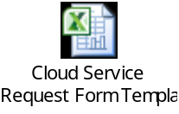
There will a separate form each type of cloud offering. For the current scope of the IAC project, there will be two Remedy forms
  - For server provisioning (Windows and Linux)
  - For Jboss Web server (JWS) provisioning

Operational Management Architecture
This section is critical for all architectures. All the support models and SLA needs should be articulated here. The procedures for maintaining the environment should be written here. Where specific groups will get involved to help support this architecture for it user base is very important here. It is not uncommon to see references to the Command Center, Administrators and the Help Desk.

Production Support

System Management
Systems will be managed as all VMs are today.

System Monitoring
This solution will be integrated with existing monitoring solution in use at Fifth Third Bank. Sitescope monitors will be setup for the provisioned IAC VMs.

Patch Management
- Patch management is required the software products used in the infrastructure as code automation platform
- Redhat Satellite Infrastructure in use at Fifth Third Bank will be leveraged for patch updates to the IAC components deployed in the Beta and production environment. For Windows, current SCCM agent/manager will be used for patching software.
- New image build can be instantiated for software patches not easy or suitable for Redhat Satellite or Microsoft SCCM. The Packer build process is flexible to incorporate software updates as code changes. Management of the paches is done in a way of code update, review and versioning.

Deployment
- All VMs (Jenkins, Terraform, Packer, etc) will be deployed in accordance with the SRM process used by service delivery.
- All VMs deployed from Terraform will adhere to Fifth Third standards.

Startup and Application Recovery
Jenkins, Terraform, and Packer can be restarted if applications fail. The Tfstate file stored in the remote backend can be used post recovery, there by ensuring that no state information is lost, even if the IAC components fail

The NAS file share will be replicated between the primary and DR datacenter, to ensure that the packer built images are made available, in case of a failure / disaster recovery

Github enterprise platform, when deployed in the bank, will ensure availability of the source code used in IAC (Jenkinsfile, packer template, Terraform module, Inspec test cases)

High Availability
N/A

Disaster Recovery
The information about the disaster recovery requirements of IAC is detailed in the LDRPS system. Please refer to LDRPS for further information

Mechanisms for Quality Requirements

Performance Architecture
Performance plans and designs should be detailed in this section. Typically links to performance test results, future plans, and SLAs can also be linked here. Performance goals can also be articulated here.
Many times architectural decisions are modified based on the performance needs, so architectural decision docs can also be linked in here.

Load Balance Model
N/A

Pooling Techniques

Hardware & Software Distribution and Management Plan

Architecture Scaling Model (Scale-Up or Scale-Out)

Load Testing Mechanisms

Vendor Related Information
The section is marked to handle any pertinent information about the vendors used in this solution. Any unique technical scenarios about a vendor’s solution can also be articulated here.

Vendor Overview
HashiCorp is a San Francisco-based company that offers products to simplify the creation and maintenance of data center infrastructure. Their products also ease application development and delivery.

Proprietary Communication
N/A

Proprietary Database Formats
N/A

Development Architecture
This section should only be used when developing or customizing applications. Use this section to articulate all development decisions and design paradigms that are relevant to the architecture. This section should be written from the point of view of a junior developer on this platform.

Language Stack
Java , Ruby files, Shell scripting, Golang

Design Patterns
Producer-Consumer design pattern is used for managing the control flow between
the Jenkins pipeline that pulls Remedy data and the Jenkins pipeline that processes
the Remedy data.

The Jenkins pipeline that pulls in the Remedy requests is scheduled to execute every 15 minutes. The Jenkins pipeline that processes the Remedy request is scheduled to run every 5 minutes to identify requests that need to be fulfilled

Both control and data flow is handed off by the Request processor pipeline to the Provisioning pipeline

Tools Used
- Git tool
- Openstack Glance
- Packer
- Terraform
- Jenkins
- InSpec
- VMware SDK
- AWS API

Third Party or Open Source Libs

Versioning Strategy

Source Code Management and Packaging
- An organization will be created in Git with the name “Cloud Engineering”.
- Under Cloud Engineering organization, there will be 3 repositories
  - Windows VM Provisioning
  - Linux VM Provisioning
  - JWS provisioning
- For every automation use case (or offering on the service catalog), a separate repository should be created under the Cloud engineering organization
- Within each repository, the following branches will be created
  - Off premises virtual private cloud development
  - Off premises virtual private cloud test
  - Off premises virtual private cloud release 001
  - On premises private cloud development
  - On premises private cloud test
  - On premises private cloud release 001

- All the above branches will have the Master branch as the Parent / Trunk
- Within each branch, the following types of files will be stored and version controlled
  - Packer files (for image build)
  - Terraform file (for image provisioning)
  - Inspec test cases (for smoke testing of the Packer images)
  - Inspec test cases (for functional testing of the provisioned VMs)
- To start with there will be only one release of the infrastructure code, and hence there will a single release branch (i.e., 001)
- With each new release, there will be separate release branches from the master (i.e., 002, 003 etc.)
- At the end of development, the developer (i.e., infrastructure automation engineer) should issue a pull request on the development branch and use the GitHub mentions (@) for tagging peers for code review
- Upon successful peer review, the code will be committed to the test branch
- A pull request is issued on the test branch, in order to trigger the build and test pipeline in Jenkins
- A review is required on the test results prior to code commit to release branch
- If additional features are to be developed (for an ongoing release or for future release), then separate branches are to be created for each feature, with the development branch designated as the HEAD
- When a feature is developed, a pull request should be issued to review the feature, prior to code commit to the HEAD development branch

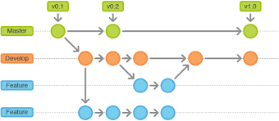
- Multiple features can be grouped together as part of a single release, and moved to a new release branch (i.e., incremental) , post testing
- While multiple release branches can co-exist, at any given point in time, there can be only one final release branch that is used in production
- Each release branch can have one or more hotfix branches (that contains the fix for code already live in production)
- When an issue is reported in production, a ticket will be created and assigned to the Infrastructure automation engineer
- The Infrastructure automation engineer in turn would create a branch from the production, in the following format
  - Release branch / Hotfix / Ticket#
- The production hotfixes will be subject to peer review and should be tested and certified prior to deployment to production. The developed code will be commited to the Dev branch of the corresponding repository in Git server. The peer reviwer will be notified of the new code. Once the peer reviewer completes the code review, he/she would forked into the test branch of the corresponding repository. The QA team is responsible for testing the code and promoting the code to production branch, upon successful test outcome. Jenkins pipeline would consume the code from the production branch
- Since GIT tool is used in IAC (as Github Enterprise platform is not setup yet), local user authentication is configured on the Git server for the following members of the Cloud engineering team
Name | ID
Venkatesan Ramanathan | t99055a
Daniel Solomon | t10664a
Lourdu Sravani Pasala | t15629a
Keerti Kothari | t15632a
Saurabh Wadhawan | t60301a

Jenkins Pipeline(s) for automated tasks

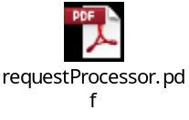
Post provisioning manual tasks

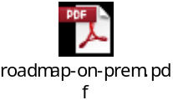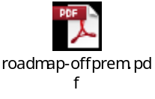

Approvals
For the minimum required signatories for this document, see Approval Matrix for PLC projects on PMO Intranet site. Additional key stakeholders may be added to ensure that all affected functional areas have been addressed.
By approving this document, the approver agrees that the content contained herein is accurate and complete; agrees to abide by the change management process identified for changes to this document; and is providing approval based on his/her role in this project (for Sign-off definition for artifact-role combination, see PMO Intranet site).

Approvals are stored with all project artifacts at: <insert path to folder where approvals are stored>.

Appendix

Architecture Decisions

Requirements Trace

Major Unresolved Issues

TBD’s

